**Day 1 Lab Assignments**

1. Create contact us page using new HTML 5 input elements and attributes, and try new form elements and the validation using CSS pseduo classes and input attributes (see the demoes and search).
2. Create new home page for your personal website using HTML5 structural elements, and use this layout.

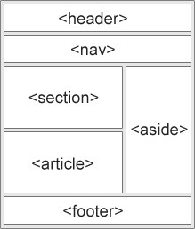

1. Try new semantic elements (Time, Meter,…).
2. Make a page (and use MicroData ont it) that contains your university (use CollegeOrUniversity schema), and write your data as one of the graduates of this university (use [alumni](http://schema.org/alumni) property and nested person schema).

**Bonus Assignments:**

1. Search for HTML5 new tags and use it, and use it.
2. Search for CSS3 new features and use it.

**<Thank>YOU </Thank>**